You can also use Latex in this website

Sharelatex: <https://www.sharelatex.com/login>

|  |  |
| --- | --- |
| It is easy to register to Sharelatex. You only need to  * add email  * create password. |  |

Sharelatex looks like this:

code pdf

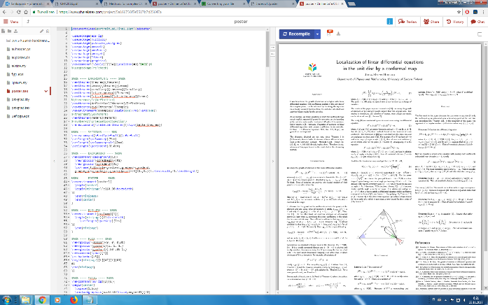

In Sharelatex, you can "Turn on link sharing".

Then you can share a project to your collaborators.  
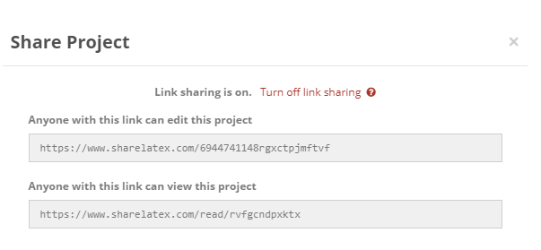

Here is my poster project: <https://www.sharelatex.com/6944741148rgxctpjmftvf>