How to record video in M100 or M107
Note. You need to order the video 1 week before!
- Google ‘uef tietotekniikkapalvelut’
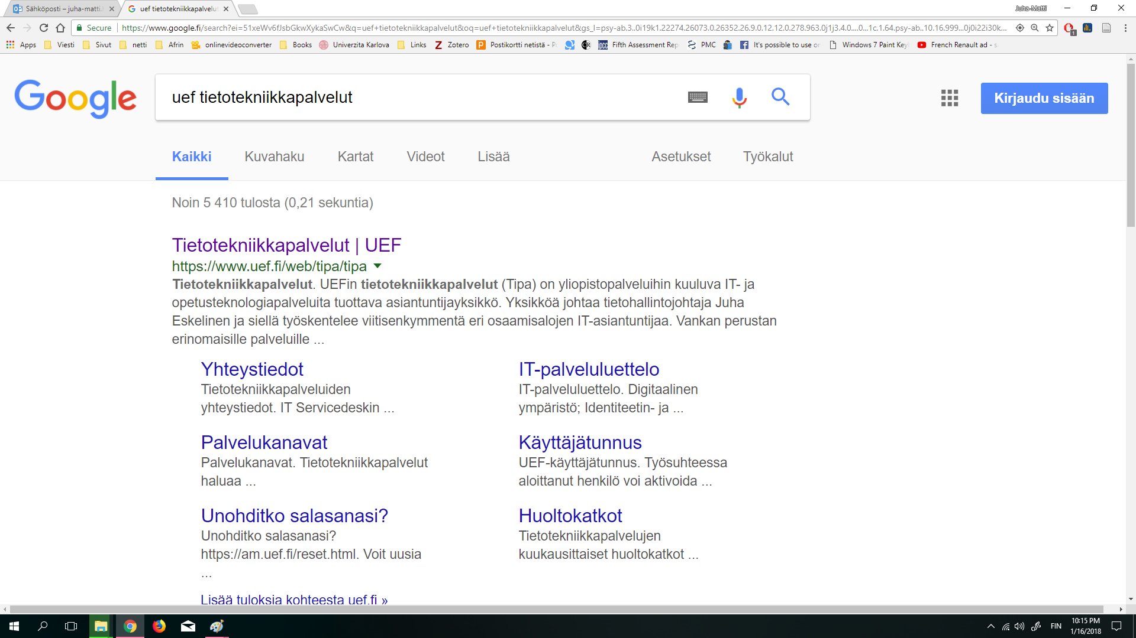

- Click ‘UEF-Asiointipalvelu’ and sign in
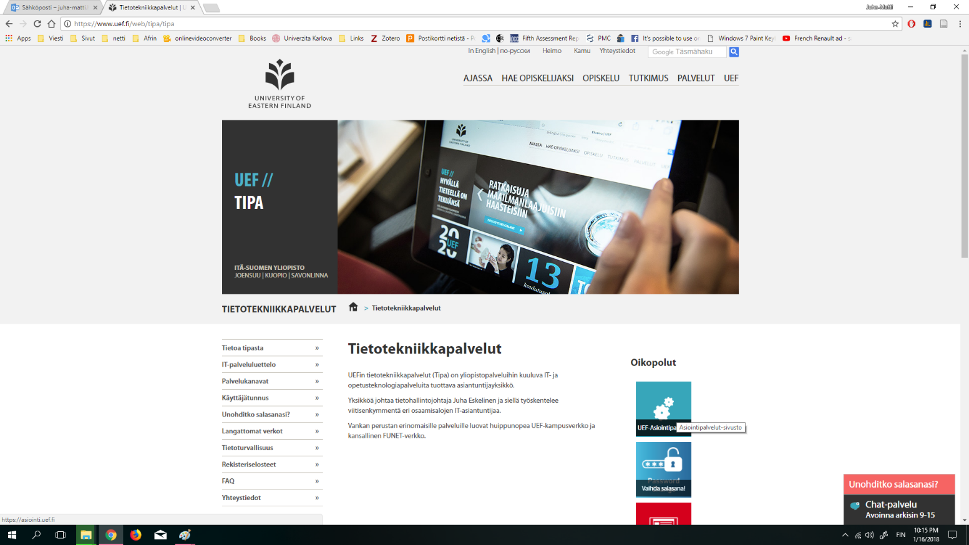
- You arrive to this kind of webpage
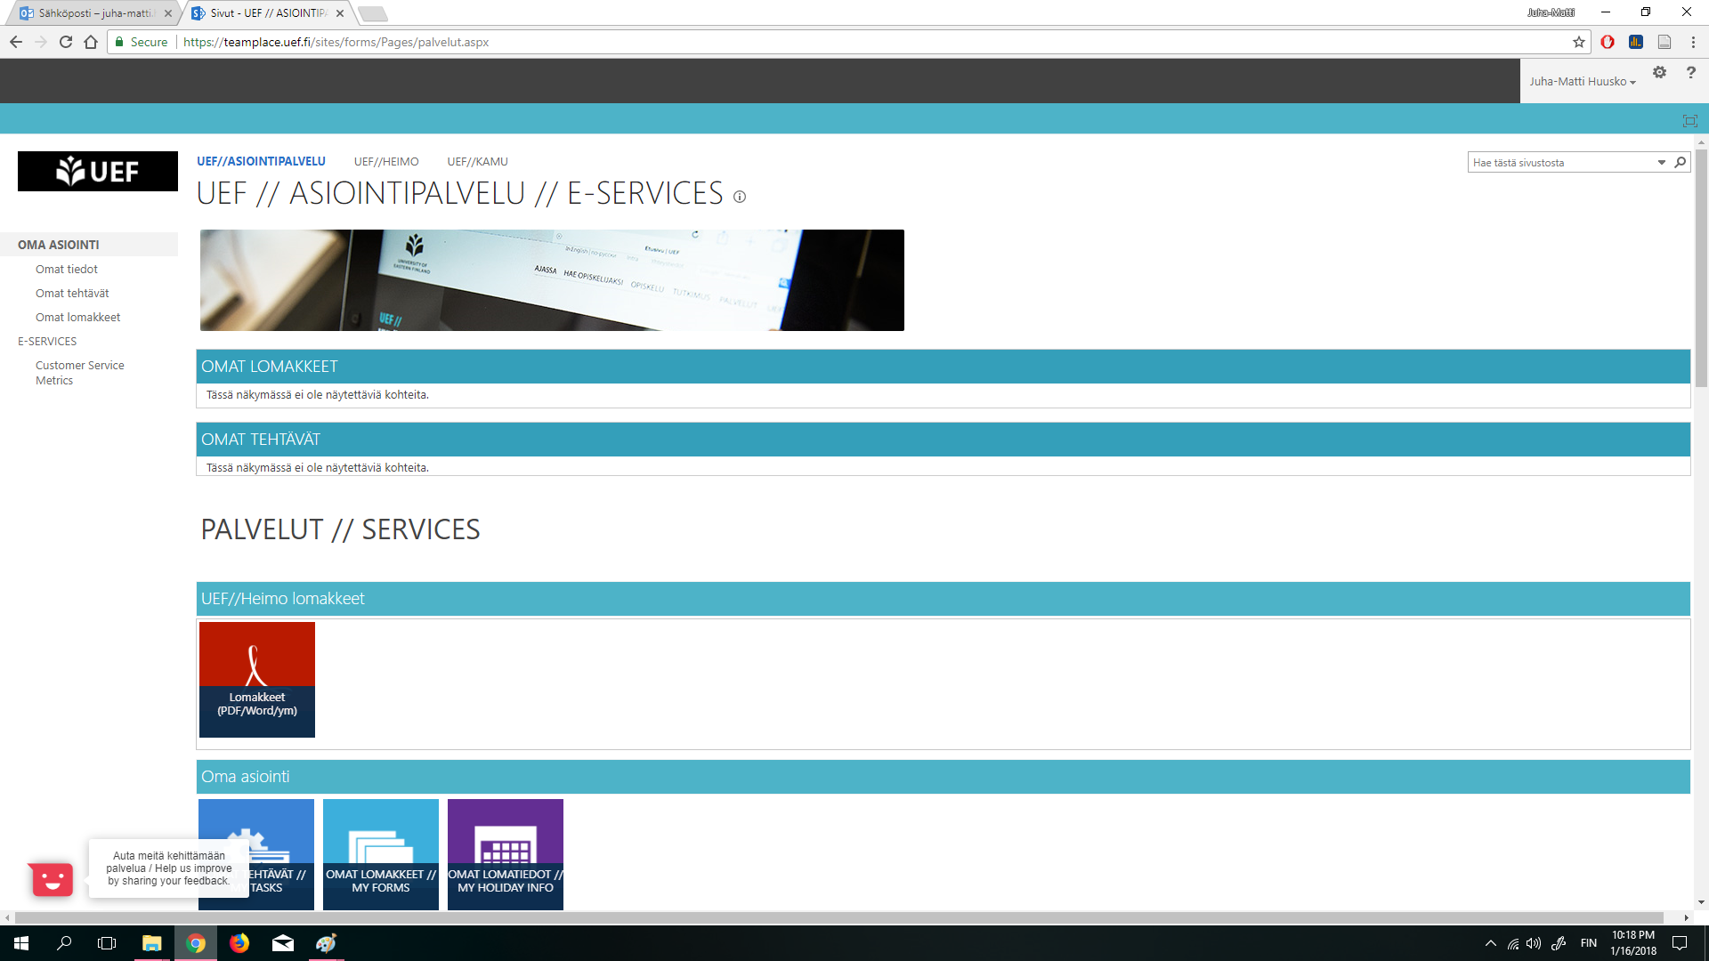

- Search the ‘Video material – ask support’ thing
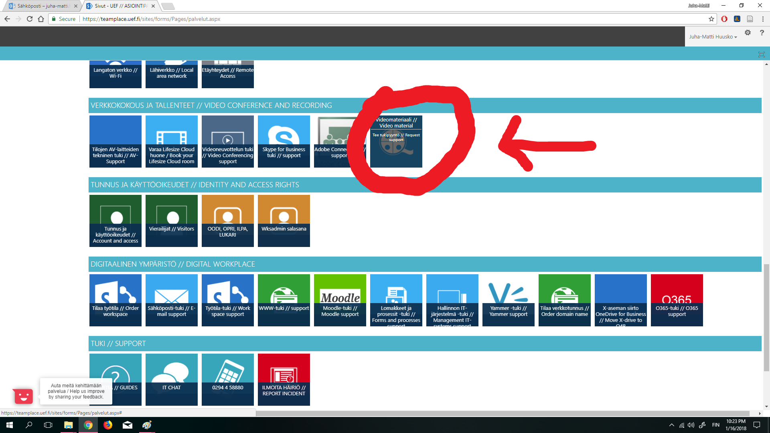

- Fill a form, ask them to record a classroom on specific time. The recording should turn on automatically
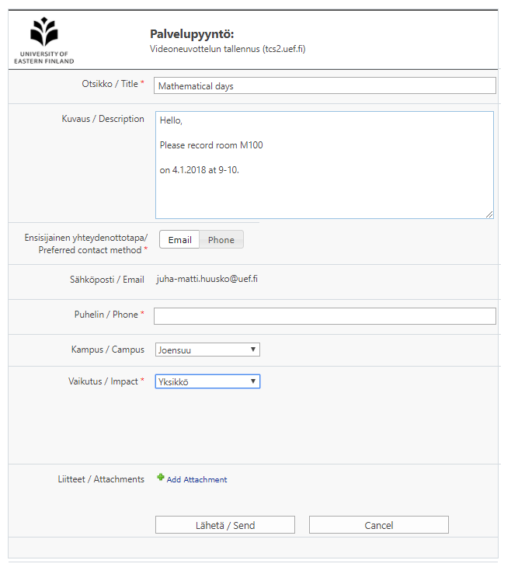

- An IT person will send you email and tell the link&password of the video
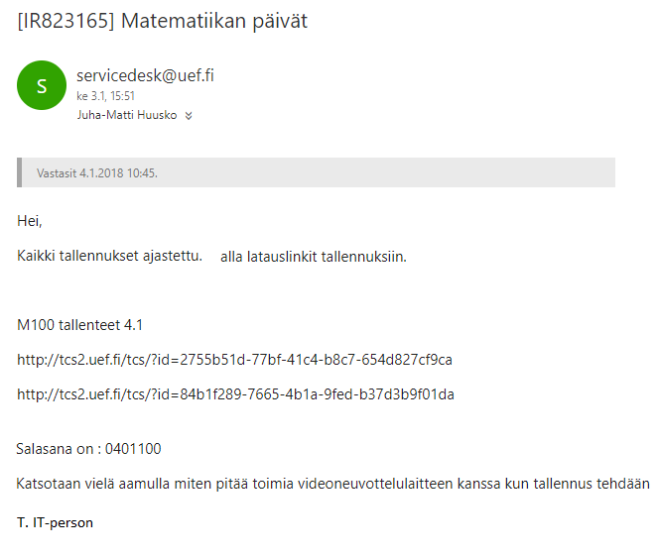

- Your lecture will take place. When the recording starts, your projector will shut down the slides. Just but them back on:
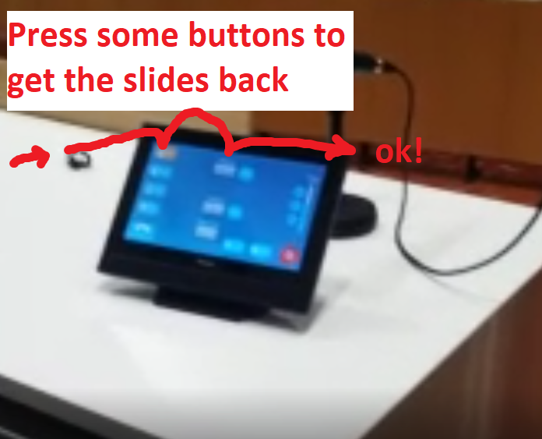
Pro tip: if your seminar is at 9:00-10:00,
ask IT to record the classroom during 8:55-10:05 (less hassle)

- Then you will wait few hours/ 1 day so that the server will process your video. Then you will use your link&password and watch/download your video.
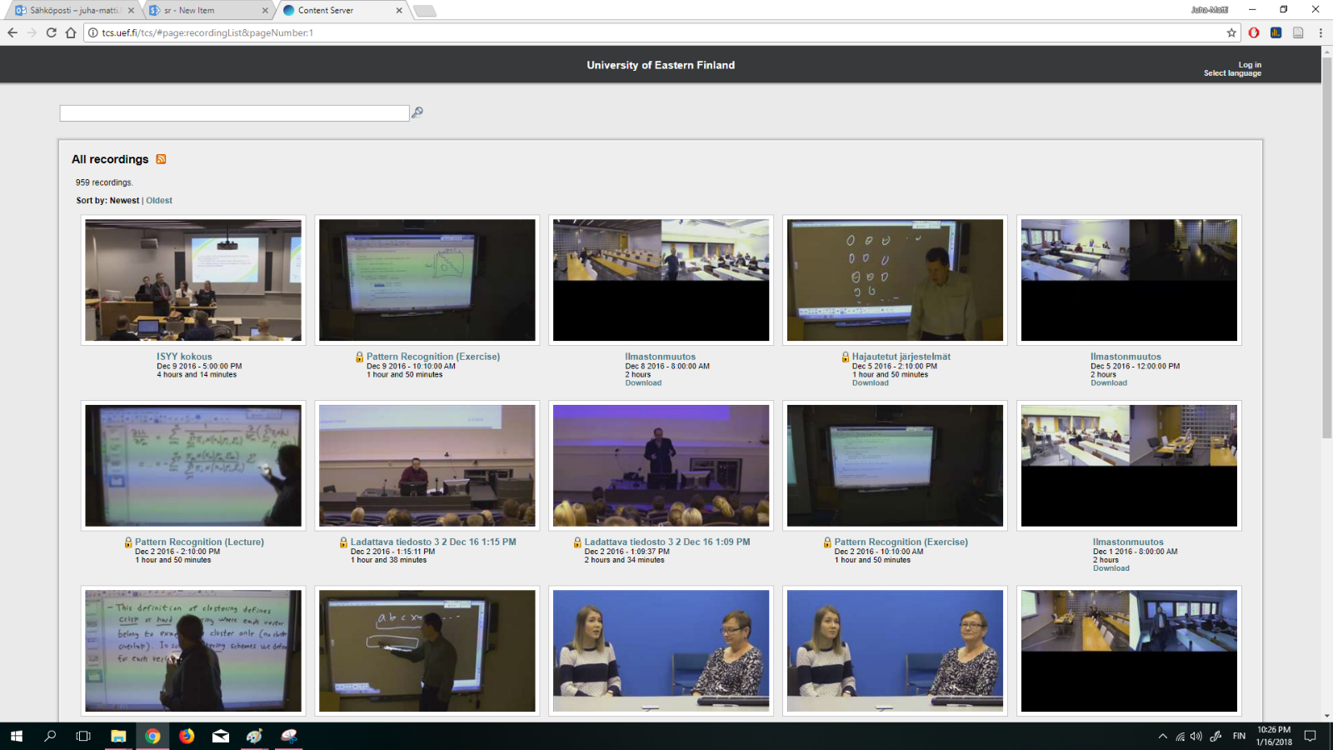
- Result…
