Dr. Juha-Matti Huusko  
 [juha-matti.huusko@iki.fi](mailto:juha-matti.huusko@iki.fi)  
 tel. +358 40 528 2815  
 April 1st 2023

**Teaching portfolio**

This document follows the instruction <https://www.aalto.fi/sites/g/files/flghsv161/files/2019-12/teaching_competence_assessment_guidelines_for_candidate_2019_aalto_university.pdf>

Contents

1. Approach to teaching and learning 3

My conception of teaching and learning 3

How I teach 3

Justification for my way of teaching 3

My son and Montessori teaching 4

2. Teaching experience 4

3. Curriculum development and educational leadership 4

4. Development as a teacher 4

Record of pedagogical studies 4

Key learnings from pedagogical studies and development of teaching skills 5

5. Feedback 5

Appendices 7

Table 1. Teaching experience 7

Table 2. Supervision experience 8

Appendix 1. Email discussion with a student. 9

Appendix 2. Systematic summary of course feedback from students 10

Appendix 3. Examples of open or other feedback from students, peers and external partners 10

Appendix 4. Structure of mathematics studies 11

Appendix 5. JSXGraph visualization about a matrix and its inverse matrix 11

Appendix 6. JSXGraph visualization about Discrete Fourier transform, its inverse; and FFT 12

# Approach to teaching and learning

## My conception of teaching and learning

I believe that every person in the world has unique capabilities and circumstances to create something new. Whatever background and experiences you have, you will get a chance to utilize them at some point. I don’t wish anybody to suffer from harsh experiences; however, if some of those experiences cannot be avoided, they can point mistakes in the society or prove useful in other way.

Every person is precious the way they are. When it is your time to make an impact, it is your responsibility to speak up and teach the world.

Therefore, education is not just for passing knowledge to the best students. Education is for learning work routines, social skills, and opening horizons for everybody. Each student learns the subject matter the amount what is possible for them at that time. Some knowledge and skills come to our everyday toolbox; some others reappear one day.

## How I teach

I wish to encourage the best students to achieve higher goals. At the same time, I want to support students with challenges. Therefore, the assessment criteria need to be clear, so everyone can focus to their goal: what is enough to pass the course; and what is enough for grade 5/5.

The path to simply pass the course should be straightforward. Most exercises should be based on examples. On the other hand, everyone should have a chance to discover things themselves – an idea which comes from socio constructivist learning philosophy.

To motivate and to set future goals, the context of the course in the tree of knowledge should be explained. See Appendix 4.

I interact with the students in a down-to-earth fashion. We focus on the course topics but also share personal experiences such as:

* One semester, I taught pendulums in a physics class for two groups. To make the pendulum visible, I climbed on a table. While climbing, I tore two sets of jeans during the same week! (Example of work safety.)
* My ex-flat mate passed a course on power series after trying the exam four times. Exams can make people frozen. (Let’s value also exercises in course evaluation.)

I am available to the students also in the hallways and after the courses. I greet students who calculate in cafeterias and might ask how they are doing. Whether they are studying my course or something else, I try to support them.

## Justification for my way of teaching

For two years, I was coaching first year university students in their homework. Exercises and exams should have a task, which you can do first to get you going and to boost your confidence. A good principle for exam questions is: if you can draw a picture, you will get at least one point.

I have got feedback that my video lectures are very peaceful and that my exercise sessions are relaxed.

Sometimes my approach does not work. Some students have a too large knowledge gap to be able to approach the course. I should discuss with them to find other ways for them to learn.

Best example, what I have seen, is from my doctoral studies. On lectures, we worked with complicated things step-by-step, with no rush. After each result, we noted it’s key features. We proceeded hierarchically with only the tools which we had at that time. However, this approach did not give the overall perspective to the topic, the big picture.

## My son and Montessori teaching

My son is now 1.5 years old. With him, we found a YouTube channel about Montessori activities, what we implement in our home. I am learning how every person has their own activities and learns through them. Someday, this will approach will affect my university teaching too.

# Teaching experience

I have a vast teaching experience in University of Eastern Finland. The lists of courses are in Appendices, in Table 1. But the experience is explained here.

During 2008-2009, I coached first year students in their homework. Unfortunately, there are no documents from this work available.

In 2011-2014, I was a teaching assistant in various courses. Most of the courses were about analysis. Analysis III contained things about integrals and series. In Numerical analysis, we calculated things via Matlab. The course I have taught the most, is Introduction to Fourier-analysis. I have taught the exercises 3 times and the whole course once – I began this journey in 2012 and taught the exercises again in 2022.

However, the first lectures I ever taught were in Introduction to topology 4 ECTS. My doctoral advisor planned the thing very well. In 2014, I taught the exercises of the course. Then in 2015, I was well prepared to teach the lectures. I re-taught the lectures in 2016.

Later on, I have taught various courses from first year courses to doctoral level courses.

# Curriculum development and educational leadership

I have taken part in the developing of teaching at Department of Physics and Mathematics in  
University of Eastern Finland. We have discussed e.g. the structure of studies, mandatory and  
voluntary courses, use of calculators in exams and electronic exam solutions.

In UpTech project, we discussed the structure of studies for DI students. We planned the structure in Excel files discussing details with various teachers. I added application related exercises to the first-year mathematics courses.

Myself, I have been developing visualizations in JSXGraph Javascript library. See Appendices 5-6. I presented a method for 3D visualizations, which the JSXGraph developers will add to the official library. A learning platform requested to use my approach to 3D visualizations. My examples have been discussed also in a master’s thesis. I am not supervising that thesis and I think it is still not completed.

# Development as a teacher

## Record of pedagogical studies

I am a qualified teacher in mathematics and physics. I completed my pedagogical studies, 60 ECTS, in my master’s degree in September 20, 2013.

## Key learnings from pedagogical studies and development of teaching skills

In the pedagogical studies, the socio constructivist learning theory was emphasized. Its idea is that  
teachers create a suitable situation for the students to experiment and construct the knowledge  
themselves. The social aspect is that if the students work in teams and then the teams debate  
each other the construction process becomes more active and deeper. Most of the socio  
constructivist learning theory is reasonable and meaningful in teaching solutions. I prefer to use  
the tools when they are applicable.

Some necessary theory can be introduced in the classroom or via short videos. The students can  
utilize the ideas from examples and solve related exercises. The creative work and team work can  
be encouraged. Students can experiment with problems and visualizations.

**My development.**

I have evolved from a quite shy teaching assistant to a more confident lecturer. In my teaching, I have now the confidence to try new things where it seems meaningful. However, if there is no reason to do things otherwise, a common course structure of the department is fine. Let the students be surprised by the mathematical phenomena instead of the surprising choices.

To develop myself more, I consider that I would learn the most, if I could teach different courses to different audiences. At the same time, I could produce materials for such courses.

Moreover, when a different teacher teaches a course, some new inventions in exercises and  
materials are made. For example, I have had two good experiences I would like to mention.

1. I taught Euclidean geometry in 2018. Unlike the standard course in UEF, I gave more  
   emphasis on the classical results from Euclid’s Elements. During each week, the exercises  
   contained a task to make an origami. Also, the exam contained one origami task with the  
   option to bring your own origami paper!
2. In Autumn 2021 I taught the course Basics in Fourier Analysis. There were also two English  
   speaking students, so I recorded the videos in both Finnish and English. I would love to  
   teach the topic again. Now I would be capable to produce dynamic images explaining many  
   concepts.

I would be interested to teach some topic, which I have not taught before. For example,  
differential equations or number theory.

As mentioned, I have completed my pedagogical studies during my master’s degree. Nowadays, I participate in  
events where I can learn about teaching. For example,

* I took a course on producing electronic exams in Abitti system.
* I have participated in Integraalipäivät teaching event in Helsinki this spring.

# Feedback

**Student feedback; evidence based on courses delivered.**

I get most of my feedback face-to-face in relaxed teaching sessions. However, something in written is in Appendices 1-3.

**Other feedback (from fellow teachers, superiors etc.)**

I gave a teaching sample on 4.6.2021 and it was rated that I did “very well”. See more at Appendix 7.

**Credentials and rewards received.**

None.

# Appendices

## Table 1. Teaching experience

1. **Bachelor’s level courses**

|  |  |  |  |  |  |
| --- | --- | --- | --- | --- | --- |
| Year | Name of the course | University | No of enrolled students | My role in the course | Status of the course |
| 2023 | Measure and integration theory | UEF | 4 | teaching assistant | optional, 4 ECTS |
| 2023 | Linear algebra b | UEF |  | teaching assistant | compulsory, 5 ECTS |
| 2023 | Differential and integral calculus | Aalto University | 60 | responsible teacher | compulsory, 5 ECTS |
| 2023 | Differential and integral calculus, (University Pathway) | Aalto University | 15 | responsible teacher | compulsory, 5 ECTS |
| 2022 | Differential and integral calculus | Aalto University | 240 | responsible teacher | compulsory, 5 ECTS |
| 2021 | Differential calculus in several variables | UEF | 54 | responsible teacher | compulsory, 9 ECTS |
| 2020 | Introduction to analysis | UEF | 60 | teaching assistant | compulsory, 4 ECTS |
| 2020 | Introduction to mathematics | UEF | 60 | teaching assistant | compulsory, 4 ECTS |
| 2019 | Euclidean geometry | UEF | 40 | responsible teacher | optional, 4 ECTS |
| 2019 | Algebra a | UEF | 50 | responsible teacher | compulsory, 4 ECTS |
| 2015? | Complex analysis a | UEF | 50 | teaching assistant | compulsory, 4 ECTS |
| 2013? | Analysis III | UEF | 40 | teaching assistant | compulsory, 8 ECTS |

1. **Master’s level courses**

|  |  |  |  |  |  |
| --- | --- | --- | --- | --- | --- |
| Year | Name of the course | University | No of enrolled students | My role in the course | Status of the course |
| 2022 | Introduction to Fourier analysis | UEF, Oulu | 26 | teaching assistant | optional, 9 ECTS |
| 2020 | Introduction to Fourier analysis | UEF | 19 | responsible teacher | optional, 9 ECTS |
| 2014, 2012 | Introduction to Fourier analysis | UEF | 15, 15 | teaching assistant | optional, 9 ECTS |
| 2015, 2014 | Introduction to topology | UEF | 15, 15 | responsible teacher | optional, 4 ECTS |
| 2013 | Introduction to topology | UEF | 15 | teaching assistant | optional, 4 ECTS |
| 2012 | Numerical analysis | UEF | 10 | teaching assistant | optional, 8 ECTS |

1. **Doctoral level courses**

|  |  |  |  |  |  |
| --- | --- | --- | --- | --- | --- |
| Year | Name of the course | University | No of enrolled students | My role in the course | Status of the course |
| 2019 | Seminar on K. Yamanoi’s paper: Zeros of higher derivatives of meromorphic functions in the complex plane | UEF | 8 | co-teacher | optional |
| 2019 | Measure and integration theory | UEF | 15 | responsible teacher | optional, 4 ECTS |
| 2020 | Topology | UEF |  | teaching assistant | 8 ECTS |

## Table 2. Supervision experience

|  |  |  |  |  |
| --- | --- | --- | --- | --- |
| Name of the student | University | Title of the thesis | My role | Status of the thesis |
| **Bachelor theses** | | | | |
|  |  |  |  |  |
| **Master’s theses** | | | | |
|  |  |  |  |  |
| **Doctoral theses** | | | | |
| Lasse Asikainen | UEF | Nevanlinna theory for difference operators? | co-supervisor | 20% done |
|  |  |  |  |  |
|  |  |  |  |  |
|  |  |  |  |  |

## Appendix 1. Email discussion with a student.

**Lähettäjä:** Juha-Matti Huusko [juha-matti.huusko@uef.fi](mailto:juha-matti.huusko@uef.fi)  
**Lähetetty:** torstai 10. joulukuuta 2020 11.41  
**Vastaanottaja:** Valtteri Rossi <vrossi@student.uef.fi>  
**Aihe:** VS: Alkeisanalyysi Laskuharjoitus1/ Valtteri Rossi

Valtteri > Vaikka kurssipalautetta toki annoinkin sekä JoMan että tämän alkeisanalyysin osalta, niin ajattelin nyt sanoa tässä vielä ihan suoraankin että olipa kaikin puolin hyvin selkeästi ja onnistuneesti vedetty syksy vallitsevassa tilanteessa!

Hyvä kuulla! 😊 Ensi viikolla on jokin keskustelutilaisuus syksyn opetusjärjestelyistä. Epsilon ja laitos ovat keränneet palautetta ja jotakin kehitysideoitakin on ilmennyt.

Valtteri > Toki itselleni on vähän outoa ja ikävää, kun kaikki kontaktit ovat näin tietokoneen välityksellä, eikä pääse oikeasti kunnolla vuorovaikuttamaan toisten kanssa kasvokkain. Monenlaista kurssia on tässäkin syksyllä jo tullut tehtyä ja nähtyä, mutta tämä vain mielestäni toimi tosi hyvin.

Tähän olisi hyvä keksiä jotain apusysteemiä. Ehkä jokin reaaliaikainen laskeskeluhengailu.

Valtteri > Joka kerta kun palautin laskareita, jaksoit paneutua niihin vastauksiin ja selventää tarkasti missä kohdin on mennyt vikaan ja/tai mitä olisin voinut tehdä toisin, vaikka sinulla varmasti muutamat muutkin kommentit annettavina.

Hyvä kuulla! Pystyin antamaan hyödyllistä täsmäpalautetta! 😊

Valtteri > Olin katsovinani jossain kohdin, että vedät keväällä jonkun toisen kurssin harkkoja mihin osallistun (olisikohan ollut usean muuttujan diffi). Palataan siis ensi vuoden puolella asiaan 🙂 Hyvää ja rauhallista joulua sekä onnekasta uutta vuotta sinulle! 🎅🏼

Joo, olen opettamassa UMD-kurssilla. Nähdään ensi vuonna. 😊

(Vuosi sitten tein verkkokurssiprojektissa videomateriaalit, jotka kattavat noin puolet UMD-kurssista.

Opetellaan usean muuttujan diffin laskentaa ensi keväänä. Vaikka ei kannata mennä asioiden edelle, niin sanonpa varalta jo tässä vaiheessa, että videot löytyvät

* täältä <http://integraali.com/vektorilaskenta/videot/vektorivideolista.html>

* ja täältä <http://integraali.com/usean/usean-listaus.html> )

Valtteri > Mainittakoon tässä vielä vertailun vuoksi, että aloitin ensimmäisen yliopistourani LUTissa syksyllä 2012 (valmistuminen toki jäi aika pahasti vaiheeseen..). Siellä minulla oli todella suuria vaikeuksia matikan kurssien kanssa läpäisyn kanssa ja moni jäikin suorittamatta. Ne mitkä sain jotenkin "taiottua" läpi, olivat niukin naukin nollan ja ykkösen rajan paremmalla puolella. Puhutaan siis vaikeudeltaan ja sisällöltään vastaavan tasoisista kursseista kuin tämä alkeisanalyysi tai johdatus matematiikkaan. Voitkin siis kuvitella ihmetykseni kun aloin täällä huomata osaavani asioita ja sainkin lopulta JM- kurssista sen vitosen. Eivät muuten LUTin aikaiset kaverit meinanneet uskoa, vaikka näytin kuvaa Weboodista😄

Ahaa, LUT! Siellä LUTissa on ollut opettajana Tuomo Kauranne, Arbonaut-yrityksen presitentti. Todella mukava ihminen ja jutustelee paljon eri asioista. Nyt hän on jo eläkkeellä. Lienetkö Tuomoa nähnyt Lutissa?

Valtteri > Kiitokset sinulle!

Ole hyvä!

Kiitos myös sinulle! Tänä syksynä sinulta on tullut kaikista pohdiskelevimmat sähköpostit. Hyviä laskentoja ja pohdiskeluja!

Lähiopetuksessa on muutama muu ihminen, jotka pohtivat asioita kovasti ääneen. On aina hyvä asia, että asioita pääsee pureskelemaan tarkemmin.

Samoin, hyvää ja rauhallista joulua. Onnellista uutta vuotta! 😊

t.Juha-Matti

## Appendix 2. Systematic summary of course feedback from students

Most of my teaching experience is from University of Eastern Finland, which just shifted to Peppi from Weboodi. Since of this shift, all records of automatically collected feedback have been lost.

Usually in UEF, in the courses, there are not very many students. Perhaps 15 to 40 students. To protect single students of being identified, the course feedback is usually hidden. Still open answers are shown. In 2019, I got such open feedback from Algebra a: “Some of the examples did not progress the course and seemed irrelevant to the topic.”

## Appendix 3. Examples of open or other feedback from students, peers and external partners

I get the most feedback face-to-face in exercise sessions. Such as

* 2022: “Can you just explain the correct answer to us. We don’t want to discuss our answers in Zoom, because they have mistakes, and we don’t have the tools to write with nice handwriting.”
* 2021: “It has been really relaxed to be here in the exercises. Earlier, I studied in Oulu. There the assistant was mean, if somebody made a mistake, people would be laughing. Do you teach any other courses?”
* 2017: “Do you teach any other courses? In your course I could learn something.”

## Appendix 4. Structure of mathematics studies

Available at <https://flinga.fi/s/F6P47YX>

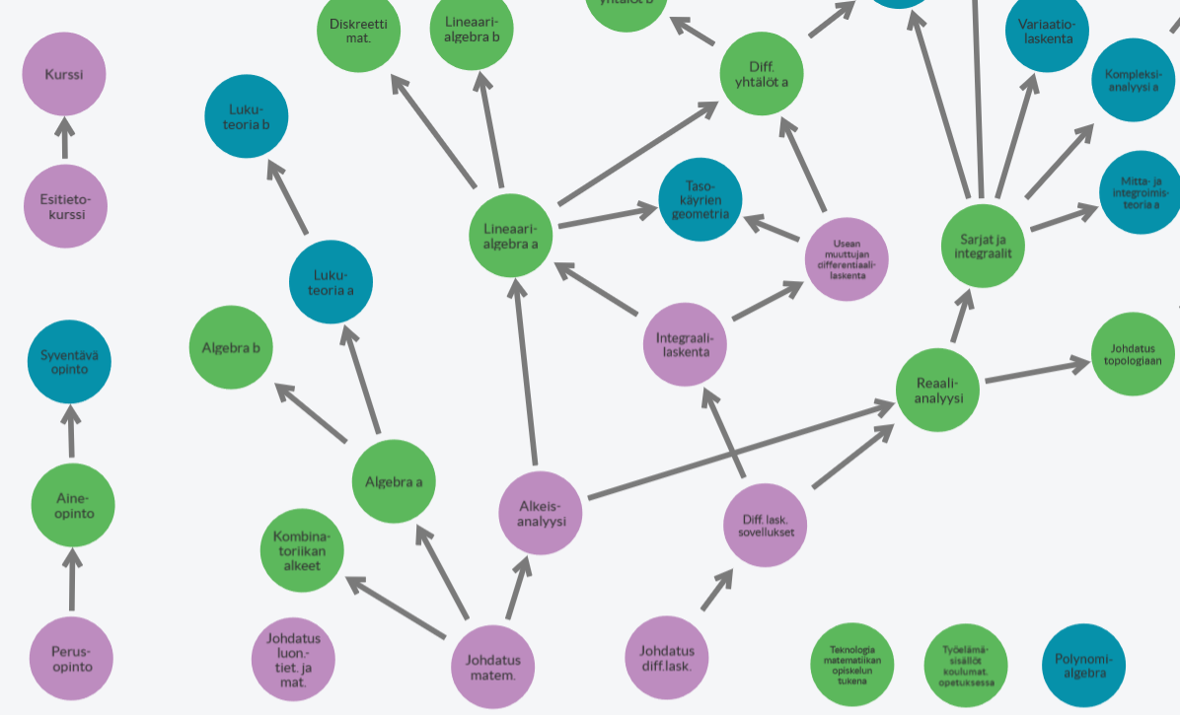

## Appendix 5. JSXGraph visualization about a matrix and its inverse matrix

Available at <http://integraali.com/jsxgraph/kuvat/lineaarialgebra/matr-ja-kaant-matr.html>

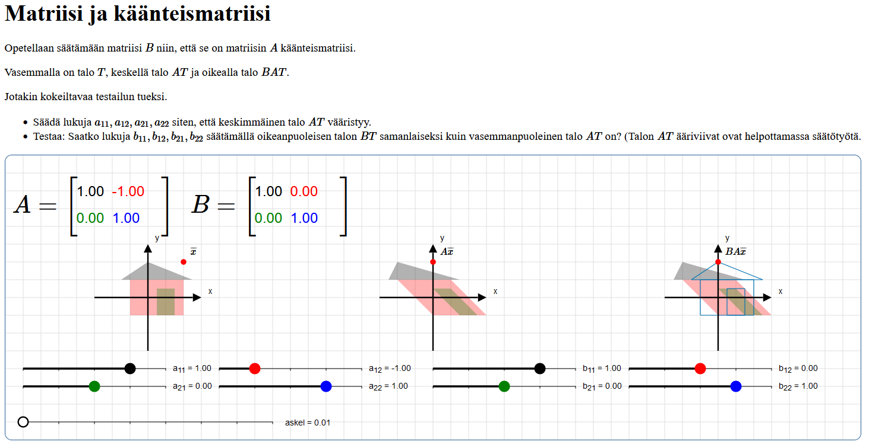

## Appendix 6. JSXGraph visualization about Discrete Fourier transform, its inverse; and FFT

Available at <http://integraali.com/fourier-havainnollistus/kuvat/diskreetti-FT.html>

and at <http://integraali.com/fourier-havainnollistus/kuvat/FFT-ja-selitys.html>

|  |  |  |
| --- | --- | --- |
|  |  |  |
| 1. Clearly y0 is the average of x0, x1, x2, x3. Therefore, y0 is the center of mass for the polygon. (Discrete Fourier transformation.) | 1. First z0 is the average of x0 and x2; z2 is the average of x1 and x3. Then y0 is the average of z0 and z2. (FFT) | 1. Conversely, x0 is the sum of y0, y1, y2, y3. (Inverse discrete Fourier transformation.) |

Appendix 7. Teaching demonstration.  
I gave a teaching demonstration on 4.6.2021 and it was rated that I did “very well”.

**The original text is:** Juha-Matti Huusko on antanut 20 minuutin pituisen matematiikan alan opetusnäytteen osana yliopistonlehtorin työhaastattelua Itä-Suomen yliopistossa 4.6.2021. Opetusnäyte annettiin etätoteutuksena Teamsin välityksellä. Huusko kävi opetusnäytteessään läpi kompleksiluvun käänteisluvun ja kompleksikonjugaatin käsitteet käyttämällä hyväksi videokameraa ja liitutaulua, sekä itse laatimiaan tietokonevisualisointeja kompleksitasossa. Mielestäni Huusko suoriutui näytteestä erinomaisesti.

**Google translate (via** [**https://translate.google.fi/**](https://translate.google.fi/) **) gives the translation:**  
Juha-Matti Huusko has given a 20-minute teaching sample in the field of mathematics as part of a  
university lecturer's job interview at the University of Eastern Finland on June 4, 2021. The teaching sample was given as a remote implementation via Teams. In his teaching sample, Huusko went through the concepts of inverse of complex number and complex conjugate, using a video camera and a blackboard, as well as computer visualizations he created himself at the complex level. I think Huusko did very well in the sample.

**The original document is in the next page.**